Advanced Sales & Sales Leadership Training & Consulting

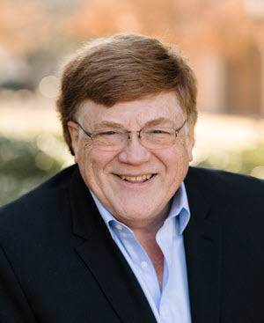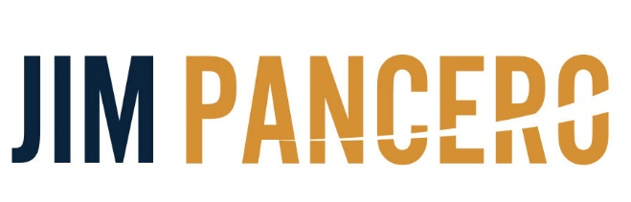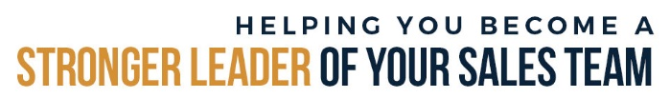

**Present**

**“How to Be a Stronger Coach and Leader of Your Sales Team”**

**Afternoon Sales Leadership**

Questions? You may contact Jim at:

952-913-8998

jim@pancero.com

**Name _________________________________________________________________________________**© Copyright 8/2019 Jim Pancero, Inc. Dallas TX

www.pancero.com

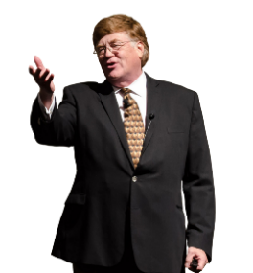

ABOUT JIM PANCERO

If you are interested…open… and ready to improve your team’s success, then Jim Pancero has answers for you. The proven selling philosophies, processes and structures Jim shares all have just one goal…to increase your personal “Powerhouse Selling Advantage.” The leading-edged ideas Jim shares have been researched, validated and fine-tuned through his over 30 years influencing and guiding top performers selling higher priced and/or competitively complex distribution materials, large equipment, or business services. Jim has conducted extensive work within the agricultural industry including training over 3,500 John Deere dealer team members in the US and Canada.

Even during a sixty-minute keynote, Jim’s combination of humor and real-world examples provides even experienced audience members who think they’ve heard it all before and are convinced there’s nothing new in sales with immediately implementable concepts that work. Jim’s proven concepts center on showing you ways to strengthen the messaging and positioning of your uniqueness and value, gaining more control of your selling processes, and strengthening your leadership team’s abilities to coach and lead in today’s hyper-competitive economy and global marketplace.

Jim’s background includes being a top performer selling large computer systems for the Data Processing Division of the IBM Corporation. During Jim's prestigious IBM career, he earned several awards including the coveted "Golden Circle" designation annually awarded to the top 5% of their international sales force.

Since founding his sales training and consulting company in 1982, Jim has conducted over 3,100 speeches, in-depth seminars or consulting days for more than 600 companies in over 80 different industries. Over 90% of Jim's clients have utilized his ideas and services more than once. Jim has also been recognized by the National Speakers Association having earned their CSP (Certified Speaking Professional) designation and been inducted into their Speakers Hall of Fame. This combined honor has only been awarded to less than 3% of their 3,500 professional members.

For more on how to increase your competitive selling advantage visit Jim’s Pancero.com website and check out his video clips on YouTube® (YouTube channel “2Sellmore”) and Vimeo.

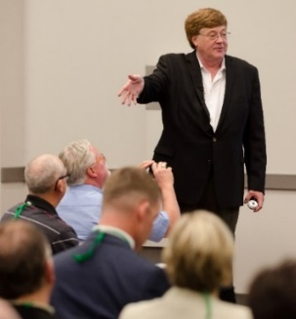

“We know you’re good. Now the only question is…are you ready to get   
even better?”

**YOU CAN DEFINE YOUR STYLE OF SALES MANAGEMENT BASED ON HOW AND WHERE YOU SPEND YOUR TIME**

|  |  |  |
| --- | --- | --- |
| **Are You Investing Your Sales Leadership Time as a Manager or a Leader?** | | |
|  | % of time spent now? | % of time needed in the future |
| **REACTIVE/SUPPORT EFFORTS** |  |  |
| Paperwork, administrative, performance analysis |  |  |
| Acting as a sales rep to your own accounts |  |  |
| Solving problems – fighting fires |  |  |
| Product ordering – Inventory management |  |  |
| Talking to customers as a manager to solve problems  - A "History" and "Today" focus  - "How can we make you happy about this?" |  |  |
| Other non-sales focused responsibilities or assignments |  |  |
| **PROACTIVE/GROWTH EFFORTS** |  |  |
| Coaching and training to improve selling "Best practices" |  |  |
| Leading sales reps through account planning |  |  |
| Riding with sales reps to observe and coach |  |  |
| Talking to customers as a manager to improve service  - A "Future" focus  - "How can we make working with us even easier and better?" |  |  |

**- *Sales managers* spend their time reactively supporting their sales team**

**- *Sales leaders* spend their time proactively leading and coaching their sales team**

**THE JOB OF A SALES MANAGER**

*“The job of a sales manager . . . is to help every one of your people   
achieve more than they would have achieved if just left alone”*

**- Are You Investing Your Sales Leadership Time as A Manager…Or A Leader?**

**- Reactive “Management” Functions**

1) Personal sales territory responsibility

2) Special pricing

3) Expediting orders

4) Problem solving

5) Paperwork, internal reports and budget/quota analysis

6) Customer “suck up” calls (“Thanks for the business”)

7) Hiring/firing

**- Proactive “Leadership” Functions**

1) Managing and motivating your people

2) Coaching/training to improve selling skills

3) Managing/coaching/leading account planning and selling strategy

4) Defining, teaching and monitoring selling “best practices”

**THE CHANGING DEFINITION OF A SALES LEADER**

**Sales managers spend majority of their time acting as “Head Doer” and little time as “Head Selling Coach”**

- Majority of sales managers are currently carrying some territory responsibilities

*- The greater your personal selling responsibilities as a manager…the more reactive you will be as a coach and leader of your sales team*

- Sales managers function more as “Transactional” sales managers than as “Selling Process”   
 coaches and leaders of their sales team

Proposal or Price Quote Issued

Selling Process Coaching

Transactional Coaching

IDENTIFY

CLOSE

**- Transactional Sales Coaching**

- Reactive – Starts after proposal is issued – “My door is always open to help”

- Major focus is to help close the business with minimal loss of margin

- *“Cut it to win it”*

**- Selling Process Coaching**

- Proactive – Starts involvement before rep makes first call on prospect (optimum) – “Get  
 in here and tell me how the Jones account is progressing.”

- Major focus is to help define account selling strategy and multiple stepped tactical implementation plan

- *“Get it set up correctly from the beginning”*

**SELLING SKILLS REQUIRED FOR SELLING SUCCESS**

**Strategic**

***Focus and Positioning***

**- Communicating Your Philosophy and Market Position**

**- Answering the Question *"Why, based on all of the competitive alternatives available to me, do I want to buy from you?"***

**Tactical**

***Tools and Controls***

**- Understanding and Controlling Your *"ID to Close"* Selling Process**

**- How to Call *"Higher and Wider"* Within a Customer's Organization**

**- How to Utilize the Rest of Your Team in Your Selling Process**

**- Time and Territory Management Skills**

**- Effective Negotiation Skills**

**Operational**

***Skills and Abilities***

**- Steps of a Sales Call**

**- Personality Awareness Skills *("Why people buy")***

**- Persuasive Communication Skills**

**- Product and Industry Knowledge**

**Attitude & Energy**

**INCREASING YOUR SALES TEAM’S SELLING SKILLS**

**- What to expect from strengthened strategic selling skills**

- The ability of your sales team to sell at higher margins because they understand you are *not* in a price driven market

- The ability to answer persuasively a customer asking them *“why, based on all the alternatives available to me do I want to buy from you?”*

**- What to expect from strengthened tactical selling skills**

- Sales professionals planning their daily and weekly activities or travel schedules in advance and in a logical way that is visible to everyone within your sales team.

- Sales professionals better able to answer where any customer currently is and what they have planned to maintain or grow their business

- Sales professionals being more proactive and initiating competitive protection activities sooner and with a higher degree of effectiveness

- More ongoing new business prospecting efforts

**- What to expect from strengthened operational selling skills**

- A more consistent and persuasive sales professional able to handle a wider range of customers, their concerns, their needs and expectations.

- A sales team who will come across to your customers as more customer focused, more professional and of more value than your competition.

**- What to expect from strengthened attitude and energy selling skills**

    - A sales team who has earned customer's loyalty due to their proven professionalism,

values, and commitment to helping.

    - A more energized, excited and harder working sales professional.

    - A "coachable" sales team open to your suggestions and guidance.

**ARE YOU A SALES *LEADER* OR JUST A SALES MANAGER?**

***"Sales Process"* Sales Coach and Leader**

**- Asks *"how"* and *"why"* questions that focuses on improving the selling process**

*- "How are you planning your next selling steps with this buyer?"*

*- "Why aren't you also talking with their financial buyer?"*

**Proactive Leadership Focused**

**Future Focused**

**Reactive Support Focused**

**- Call report analysis**

**- Industry and   
 competitive   
 analysis**

**- Coaching and  
 Training**

**- Defining and  
 improving *“Selling  
 Best Practices”***

**- Special pricing**

**- Problem/crisis  
 management**

**- Help close sales**

**- Equipment  
 acquisition and   
 expediting   
 management**

**History & Today Focused**

***“Transactional”* Sales Manager**

**- Asks *“what”* and *“who”* questions that focus on winning the transaction**

*- “What’s it going to take to close that proposal?”*

*- “Who else do you think will close this month?”*

**THE LANGUAGE OF “THE COACHING ZONE”**

|  |
| --- |
| **Future**  **- Forecasts and quotas**  **- Strategic planning**  **- Coaches team *“what to do”*  before anything is done** |
| **Today**  **- Status reports**  **- Call planning meetings**  **- Customer sales calls**  **- Problem resolution activities** |
| **History**  **- Call reports**  **- Expense reports**  **- *"What happened?"* meetings**    **- Only complains about what wasn’t**  **done after the fact** |

**Strategic**

***Focus and Positioning***

**- Communicating your philosophy and market position**

**- Answering the question *"why, based on all of the competitive alternatives available you?"***

**Tactical**

***Tools and Controls***

**- Understanding and controlling your *"id to close"* selling process**

**- How to call *"higher and wider"* within a customer's organization**

**- How to utilize the rest of your team in your selling process**

**- Time and territory management skills**

**- Effective negotiation skills**

**Operational**

***Skills and Abilities***

**- Steps of a sales call**

**- Personality awareness skills   
 *("why people buy")***

**- Persuasive communication skills**

**- Product and industry knowledge**

**Attitude & Energy**

**C:\Program Files (x86)\Microsoft Office\MEDIA\CAGCAT10\j0195812.wmf**

**- The *“Coaching Zone”* occurs when you keep your coaching   
 conversations...  
  
 *- Tactical  
 - Strategic  
 - Future focused***

Extra “stuff” that’s really important to sales leadership…

But we don’t have time to cover during our   
50-minute program

There’s never enough time to talk about sales leadership, is there?

**HOW TO STRENGTHEN YOUR "SELLING PROCESS" COACHING LANGUAGE**

**“Transactional” Sales Managers Coaching Language**

* **Tell/Lecture**
* **Focus on the negatives to fix and improve performance**
* **Think and plan for your “next best” move**
* **Focus on “history” and “today” issues**

- “What did you do?”

- “How are you going to fix this?”

- “What can you do to close this?”

* **Follow the “Golden Rule” as a coach**

- “Treat others as you want to be treated”

**“Selling Process” Coaches and Leaders Coaching Language**

* **Ask questions**
* **Focus on the positives and efforts to fix and improve performance**
* **Think and plan more moves ahead than either your customer or competitors**
* **Focus on “future” focused issues**

- “What did you learn?”

- “What do you plan to do next?”

- “What else can you do to increase your competitive advantage?”

* **Follow the “Platinum Rule” as a coach**

- “Treat others as they want to be treated (forgetting about yourself)”

**KEY COACHING LANGUAGE AND COACHING TERMS TO ASK**

***- "And then what?"***

- To help your reps think and plan more moves ahead

***- "Who else can you be calling on and improving your relationship?"***

- To help your reps get higher, wider and deeper within a customer or prospect

***- "Is this the best thing to be working on…or are there better investments of your time and attention?"***

- To help your reps focus on the "next best" most important opportunities to be pursuing

***- "Who else on your team can be helping you or doing this activity for you?***

- To help your reps stop doing everything themselves, to help them use their entire team and to become more efficient and effective in their selling efforts

***- "Are these coaching and planning sessions helping you and your selling efforts?"***

- To provide you with feedback from your rep as to the effectiveness of your selling suggestions and coaching help

***- "What else can your company and your support team be doing to help you sell more (at higher margins)?"***

- To help your reps identify how they can better use your support team to increase their selling effectiveness and results

**FOUR KEYS TO YOUR EFFECTIVE SALES LEADERSHIP MOVING FORWARD**

**1) Defined "Selling Process" tools and processes (with performance tracking)**

- Goals

- Accelerate change / Improvements

- Increase selling consistency and effectiveness

- Maintain and improve established skills and "selling best practices"

**- Tools needed**

1) One minute message of value and uniqueness

- "Why buy your company’s products?"

- Proactive positioning of "Higher price - Lower total cost" message and approach

- Measure by testing ("Tell me why I'd want to buy from you?")

2) Steps of a sales call

- Lower resistance / Questions / Present / Close / Agree-Set up next contact

- More control of sales calls under any processes

- More effective sales calls getting value and uniqueness messages delivered and agreed to by buyers

- Measure by observing reps during "Ride-With's"

3) Steps of your selling process

- New business opportunities

- Defined "Identify to close" stepped process

- "Success factors" identified for each step

- Ideas or actions that, if performed during this step, would greatly increase your chances of winning the business

- Promotes better "More moves ahead" thinking and selling

- Allows an effective tool to track sales rep focus, efforts and progress

- Existing important customers

- Defined "January 1st to December 31st" plan to maintain/improve customer satisfaction and to grow the business (and profitability)

- Defined selling and service proactive support and selling efforts

- Improves support (and stability) of most important accounts

- Helps communicate selling plans to support team and upper management

- Helps rep approach most important accounts in a more organized and proactive way thinking and planning more moves ahead

- Provides management a backup to future selling plans and efforts if your current rep leaves

- Improves account stability by helping your rep get "Higher, wider and deeper" within their important accounts

**FOUR KEYS TO YOUR EFFECTIVE SALES LEADERSHIP MOVING FORWARD…**

**2) More involved "Selling process" management through One-on-one account planning**

- One-on-one Account Planning:

- Provides a vehicle to continually improve team's selling efficiency and effectiveness

- Helps reps think and plan with a more tactical, strategic and future focused approach to their next several selling steps

- A vehicle to keep upper management informed, updated and with an easy way to provide suggestions and guidance to the entire sales team

- Provides way for front line sales managers to impact their team member's selling efforts from the beginning, not just cleaning up after the proposal was given trying to help close the business and save margin

- Involves conducting regular one-on-one and team discussions and coaching sessions

- Weekly with entire support team

- Once/twice a month with outside reps

- Each meeting involves reviewing progress with existing plans plus the development of a new plan for an existing customer or prospect

- Monthly upper management briefings with front line sales manager (one-on-one)

- Half time reviewing what accomplished with team last month

- Half time briefing on what you plan to work on this next month

**3) More active training and coaching to improve selling processes, tools and skills**

- More active training and coaching provides better:

- "Selling process" discussions within sales teams helping them better understand how to think and plan more moves ahead

- Awareness of the need to shift as a team from "Independent Gunfighters" to more of a "Selling SWAT Team"

- Awareness of the need to move from the current "Independent Silo" business model to more of a "Single Enterprise"

- Using "we and us" terms instead of "they or them"

- Provides more opportunities for sales reps to voice opinions, discuss trends and market changes as well as providing feedback to their management

- Critical to satisfying your millennial employees

**FOUR KEYS TO YOUR EFFECTIVE SALES LEADERSHIP MOVING FORWARD…**

**4) Single performance dashboard to measure selling process progress and success**

**- The four coaching levels of change**

1st - Measure change in attitude

2nd - Measure change in effort

3rd - Measure change in progress

4th - Measure change in results

**- Improve performance tracking by adding one additional question to all financial and technical customer (or prospect) discussions**

- "What step are you on with this account?" for any new business opportunities

- "What step are you on with your plans to generate new interest or growth opportunities within this existing account?"

**SALES EVALUATION**

You make take this free evaluation ***online*** at <https://pancero.com/sales/sales-pro-evaluation/>

**Rate your skill on a scale from 1 to 5. 1 = non-existent; 2 = weak; 3 = Just average; 4 = Leading; 5 = Best practice.**

**Evaluating Your *Operational Selling Skills* and Abilities**

**Understanding the technical side of your business**

1 2 3 4 5 #1 - Your technical knowledge of your products/services and how they relate to your industry?

1 2 3 4 5 #2 – Knowledge of your competitor’s products and their customer success stories?

**Understanding the Fundamentals of Selling**

1 2 3 4 5 #3 – Your knowledge and daily usage of the steps of a sales call?

1 2 3 4 5 #4 – Your understanding of personalities, ability to identify, then mirror your customer’s communication style?

**Understanding How to Manage Your Time and Information**

1 2 3 4 5 #5 – Your personal “time and territory” organizational skills?

1 2 3 4 5 #6 - Your ability to utilize technology to increase your productivity and effectiveness?

**Evaluating Your *Tactical Selling Skills* and Abilities**

**Maintaining and growing your business**

1 2 3 4 5 #7 – Your ability to proactively manage, control, and resolve customers’ problems?

1 2 3 4 5 #8 - Your ability to keep your existing accounts stable and under control?

1 2 3 4 5 #9 - Your ongoing new business prospecting process?

**Managing Your Selling Process**

1 2 3 4 5 #10 – Your ability to think and plan multiple moves ahead with each of your customers and prospects?

1 2 3 4 5 #11 – Your knowledge/understanding of competitors’ pricing practices?

1 2 3 4 5 #12 – Your ability to utilize company support resources in your territory?

**Maintaining and Controlling Your Customer**

1 2 3 4 5 #13 – Your ability to communicate what your customers want to buy instead of just what you have to sell?

1 2 3 4 5 #14 – Your understanding of the political environment and decision process of each of your accounts?

**Evaluating Your *Strategic Positioning Skills* and Abilities**

**Ability to manage the strategic aspects of your selling process**

1 2 3 4 5 #15 – Your ability to communicate what your competitive uniqueness and value is?

1 2 3 4 5 #16 – Your knowledge of your competitors’ strongest “value points” they use to sell against you?

1 2 3 4 5 #17 – Your ability to win business at a higher price/margin by communicating your stronger value?

**Your Philosophy Toward Ongoing Personal Development and Improvement**

1 2 3 4 5 #18 – Ability to represent yourself in a professional, truthful, and ethical manner?

1 2 3 4 5 #19 – Your ongoing commitment and efforts to grow and improve your selling skills and awareness?

1 2 3 4 5 #20 – Your ongoing use of one or more coaches or mentors to help you get better?

**SALES LEADERSHIP EVALUATION**

You make take this free evaluation ***online*** at <https://pancero.com/sales-leadership/sales-leadership-evaluation/>

**Rate your skill on a scale from 1 to 5. 1 = non-existent; 2 = weak; 3 = Just average; 4 = Leading; 5 = Best practice.**

**Your Role as an Administrator, Problem Solver and Disciplinarian**

1 2 3 4 5 #1 - Your skills as an organized administrator are…?

1 2 3 4 5 #2 - Your skills coaching your sales reps through problem solving are…?

1 2 3 4 5 #3 - Your skills managing and coaching the pricing and profitability decisions of your teams are…?

**Your Ability to Build and Retain a Sales Team**

1 2 3 4 5 #4 - Your *“new sales person”* searching and interviewing skills are…?

1 2 3 4 5 #5 - Your *“new hire”* sales training program is…?

1 2 3 4 5 #6 - Your *“Performance Plan”* program in place for each member of your team is…?

1 2 3 4 5 #7 - Your ongoing *“experienced sales team”* training process is…?

1 2 3 4 5 #8 - Your accessibility to your sales force is…?

**Your Ability to Lead**

1 2 3 4 5 #9 - Your sales team would rate their satisfaction level working for you as…?

1 2 3 4 5 #10 - Your amount of *“positive focused”* communications with your team is..?

1 2 3 4 5 #11 - Your ability to initiate new ideas and account planning conversations with your team is…?

1 2 3 4 5 #12 - Your ability to delegate to your sales team is…?

**Your Ability to be a Coach & Strategist of Your Selling Process**

1 2 3 4 5 #13 - Your ability to organize and lead your team as a single market force is…?

1 2 3 4 5 #14 - Your team’s ability to communicate a single message of competitive uniqueness and market leadership is…?

1 2 3 4 5 #15 - Your ongoing new business prospecting process currently in place is…?

1 2 3 4 5 #16 - Your marketing and promotional skills are…?

1 2 3 4 5 #17 - Your ability to commit time to individually coach and strategize with each of your sales reps is…?

1 2 3 4 5 #18 - Percentage of time spent talking *“future focused”* with your reps is...?

1 2 3 4 5 #19 - Your ability and time committed to talking *“tactical and strategic focused”* with your sales reps are…?

1 2 3 4 5 #20 - Your ability to communicate with customers to help your sales reps get *“higher, wider and deeper”* is…?

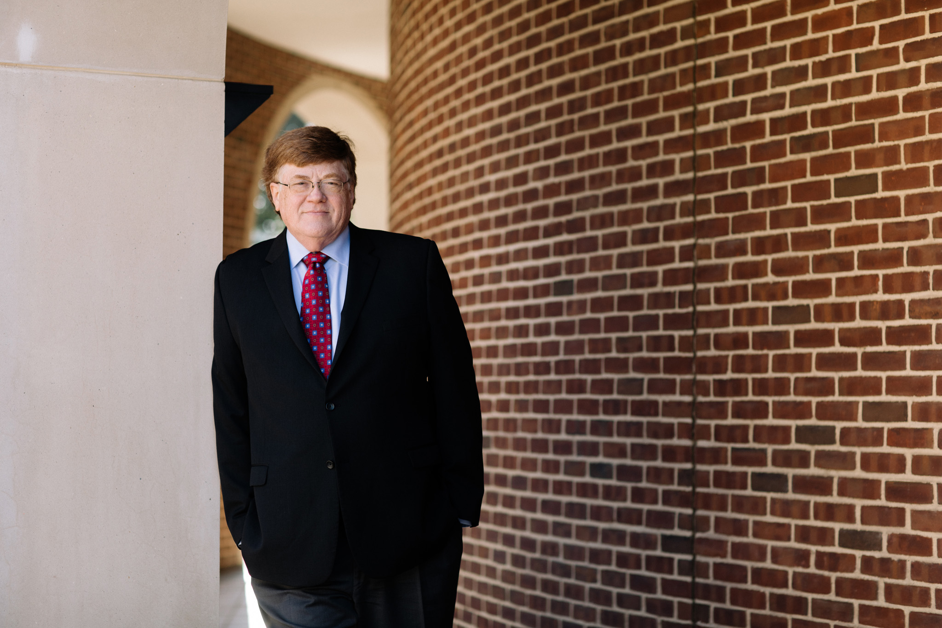

***We know you’re good, now are you ready to get even better?***

**Visit *Pancero.Com* to Enhance Your Sales and Sales Management Training**

[**Follow Jim on Linkedin**](http://www.linkedin.com/in/jimpancero) Jim is posting 3 new sales leadership videos each week on LinkedIn and Facebook! All aimed at helping you become a stronger leader of your sales team. You can view all of Jim’s past LinkedIn postings by putting hashtag #PanceroVids in the LinkedIn search window.

**Articles for Sales Pros and Sales Managers** to help you with In-House training [Click Here](https://pancero.com/articles)

**MP3's** - MP3 audio training by Jim that can be played from your phone or tablet. [Click Here](https://pancero.com/videos/audios/)

**80+ Videos** - Watch training videos. Sales and Sales Management topics are covered. [Click Here](https://pancero.com/videos/)

**Evaluate Your Skills! Free 20 Question *Sales* and *Sales Leadership* Tests!**

The 20-question multiple choice ***Sales Evaluation for sales reps***is a comprehensive analysis tool designed to help you as a sales rep increase awareness of your strongest selling skills. [Click Here](https://pancero.com/sales/sales-pro-evaluation/)

The goal of the 20-question multiple choice ***Sales Leadership Evaluation*** is to help improve your ability to lead a sales team. [Click Here](https://pancero.com/sales-leadership/sales-leadership-evaluation/)

Both tests can be taken multiple times to see how your skills are increasing and all tests results and analysis are instantly available online and emailed.



[**Connect with Jim on Linkedin**](http://www.linkedin.com/in/jimpancero)

[**Sign up for email updates!**](https://pancero.com/contact/)

