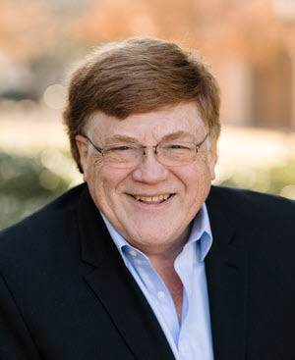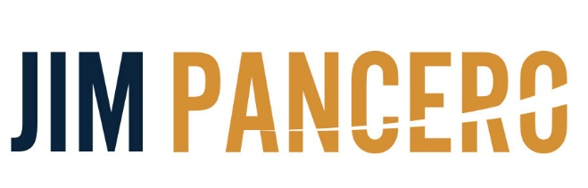

Advanced Sales & Sales Leadership Training & Consulting

**Present**

**“How to Capture the Higher Value   
You Deserve”**

**Morning Keynote**

Questions? You may contact Jim at:

952-913-8998

jim@pancero.com

**Name _________________________________________________________________________________**© Copyright 8/2019 Jim Pancero, Inc. Dallas TX

www.pancero.com

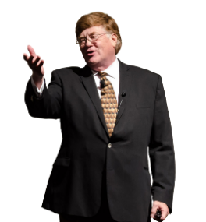

ABOUT JIM PANCERO

If you are interested…open… and ready to improve your team’s success, then Jim Pancero has answers for you. The proven selling philosophies, processes and structures Jim shares all have just one goal…to increase your personal “Powerhouse Selling Advantage.” The leading-edged ideas Jim shares have been researched, validated and fine-tuned through his over 30 years influencing and guiding top performers selling higher priced and/or competitively complex distribution materials, large equipment, or business services. Jim has conducted extensive work within the agricultural industry including training over 3,500 John Deere dealer team members in the US and Canada.

Even during a sixty-minute keynote, Jim’s combination of humor and real-world examples provides even experienced audience members who think they’ve heard it all before and are convinced there’s nothing new in sales with immediately implementable concepts that work. Jim’s proven concepts center on showing you ways to strengthen the messaging and positioning of your uniqueness and value, gaining more control of your selling processes, and strengthening your leadership team’s abilities to coach and lead in today’s hyper-competitive economy and global marketplace.

Jim’s background includes being a top performer selling large computer systems for the Data Processing Division of the IBM Corporation. During Jim's prestigious IBM career, he earned several awards including the coveted "Golden Circle" designation annually awarded to the top 5% of their international sales force.

Since founding his sales training and consulting company in 1982, Jim has conducted over 3,100 speeches, in-depth seminars or consulting days for more than 600 companies in over 80 different industries. Over 90% of Jim's clients have utilized his ideas and services more than once. Jim has also been recognized by the National Speakers Association having earned their CSP (Certified Speaking Professional) designation and been inducted into their Speakers Hall of Fame. This combined honor has only been awarded to less than 3% of their 3,500 professional members.

For more on how to increase your competitive selling advantage visit Jim’s Pancero.com website and check out his video clips on YouTube® (YouTube channel “2Sellmore”) and Vimeo.

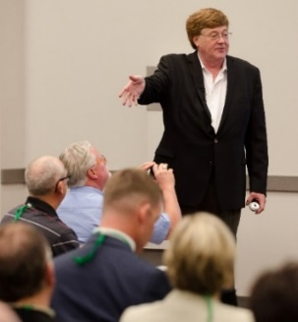

“We know you’re good. Now the only question is…are you ready to get   
even better?”

**DEALING WITH THE REALITY YOU ARE NOT IN A PRICE DRIVEN INDUSTRY**

**- Price is never the primary determinant in a customer’s competitive buying decision**

- 1st a buyer looks for a **difference in *value***

- Only 2nd (when no difference in value) do you look for a **difference in *price***

**- How is your sales/service team selling your *“Higher price – lower total cost”* solutions?**

**- Your buyer’s definition of value they are willing to pay more for is dramatically changing**

- The challenge with today’s *“Competitive Swarm”* impacting buyer’s pricing expectations

**IF I’M NOT IN A PRICE DRIVEN ENVIRONMENT…THEN HOW COME THERE IS SO MUCH PRICING PRESSURE?**

**- Buyers will negotiate:**

**1) Because they can.**

- The more vendors calling on me the more I’ll try negotiating better terms or a better price.

**2) When they see little to no value differential between vendor alternatives.**

- The greater the differential in value perceived then the greater the differential

in value that will be paid.

**3) When they receive demands or pressure from their bosses.**

**4) When they are not getting what they really want or need.**

**5) When your price is significantly higher than what they have paid in the past.**

**6) When they perceive weakness in the seller.**

**7) When they personally view negotiating with a vendor as a sport or game.**

**ARE YOU SELLING LIKE AN “INDEPENDENT GUNFIGHTER?”**

**- What is your definition of a professional?**

- My definition…A professional is defined by their consistency of performance

**- What is the philosophy of you and your sales team?**

***- “Independent Gunfighters” – Old school “baby boomer” style***

- Like a gunfighter in the old West, treats each customer or selling situation as a  
 unique selling opportunity or challenge

- Each customer gets a unique selling message of value to best fit what they said they wanted (no matter what they said they wanted)

- Each customer is sold in a different way or approach…no consistency of their  
 multiple stepped selling process

- Nothing is learned or gained from either a win or loss since the next customer  
 will get their own unique approach anyway

- Sees themselves in direct competition against all the other reps on their team.

- Manager only learns about a new selling opportunity after a proposal or quote is delivered

- Wants as little management attention as possible. Only wants to use their manager for special pricing, expediting, problem solving, or customer visits

***- “Selling SWAT Team” – More competitive “Millennial” style***

- Sales team defines, and then follows a consistent multiple-stepped selling process  
 and message of value and uniqueness

- What is learned through the win or loss of an individual sales provides learning, input and value to the entire sales team helping all make the next selling opportunity even more efficient and successful

- Encourages an “Us against the rest of the world” team philosophy so team members encourage and support each other

- Manager involved from the beginning of the sales planning efforts so the first  
 positioning efforts are effective and successful

- Active involvement with their sales manager to help develop account plans and next best steps to be taking

**TODAY’S CHALLENGE – SALES REPS BROUGHT IN LATER IN THE BUYING PROCESS**

Sell to the challenge and positions Bid to Win Support to maintain and grow

**1**

**2**

**3**

**4**

**5**

ID solution direction

ID solution providers

ID vendor winner

ID how solution implemented

ID Pain

Maintain solution satisfaction

**6**

**Steps of the buyer problem resolution process**

**1st Step – Agree on pain**

- “Is this problem big enough that it needs to be fixed?”

- Successful sales reps identify and uncover problems buyers do not know they have (or   
 do not understand the severity/consequences)

**2nd Step – Agree on solution direction**

- “Is it better to solve this with more automation…or more worker training?”

- Successful sales reps develop inside buyer champions to their solution direction before  
 buyers realize they even have a problem that needs fixing

**3rd Step – Agree on potential solution providers**

- “Who do we want to consider fixing this?”

- Successful sales reps position their company, products and services in advance of any  
 bidding so they get the chance to propose and be heard

**4th Step – Agree/select final vendor(s)**

- “Who is the best choice to fix this?”

- Successful sales reps win business by positioning and proving (from the beginning) how  
 you will be a lower risk and lower total cost to your buyers (even when you are a higher  
 price)

**5th Step – Agree on solution implementation process, timeframes and responsibilities**

- “Who will lead (or support) this solution implementation?”

- Successful sales reps sell a more proactive, vendor-led solution to create (and provide)  
 more value, a lower risk, and ultimately a lower total cost to their buyers

**6th Step – Agree on who will take responsibility to maintain this solution**

- “Who will maintain this solution and make sure it never happens again?”

- Successful sales reps position their company as a proactive provider of solutions and  
 support so you will be first-in-mind for any reorders and/or additional solutions

**- What can you and your team do to get in front of your buyers earlier in their problem  
 resolution process?**

**THE EVOLUTION OF A COMPETITIVE ADVANTAGE**

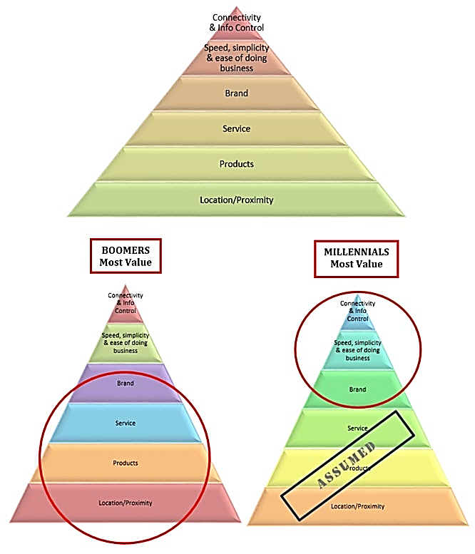

**WHERE DO YOUR CUSTOMERS SEE YOU?**

**Trusted Advisor**

- Increasing customer order size and loyalty

**Business Growth and Profit Generator**

- Offering new ideas and suggestions

***"Specials"* Presenter**

- Covering as many *"special deals"* as possible

**Order Taker / Problem Solver**

- Taking care of your customer's problems

**CAN YOU SHIFT TO A MORE PREDICTIVE/PROACTIVE SERVICE PHILOSOPHY?**

**Where are your support levels now?**

**- Write down the five best “things” your customer services team are doing now to   
 contribute to your customer’s experience**

1. **_____________________________________________________________________________________________________**

**2. _____________________________________________________________________________________________________**

**3. _____________________________________________________________________________________________________**

**4. _____________________________________________________________________________________________________**

1. **_____________________________________________________________________________________________________**

**- The four levels of customer service**

1. **_____________________________________________________________________________________________________**

**3. _____________________________________________________________________________________________________**

**2. _____________________________________________________________________________________________________**

**1. _____________________________________________________________________________________________________**

**- The evolution of customer service and support as a competitive advantage**

1st – (Oldest) – Service based on responsiveness

2nd – Service based on preventative efforts

3rd – Service based on predictive efforts

4th – (Newest) – Service based on “condition-based monitoring”

**WHERE DO YOUR CUSTOMERS SEE YOU?**

**Trusted Advisor**

- Increasing customer order size and loyalty

**Business Growth and Profit Generator**

- Offering new ideas and suggestions

**PROACTIVE**

(Loyalty to sales rep and company)

(No loyalty to sales rep or company)

**REACTIVE**

***"Specials"* Presenter**

- Covering as many *"special deals"* as possible

**Order Taker / Problem Solver**

- Taking care of your customer's problems

**KEYS TO COMPETITIVE ADVANTAGE AND INCREASED SALES**

**1) Strong response to *“Why buy from you?”* consistently delivered by your entire team.**

**2) Defined (and coached to) “Selling Process Best Practices.”**

- Steps of a Sales Call

- *“ID to Close”* new business selling process.

- “1/1 to 12/31” processes to support your best customers.

- Operational *“Steps of a Sales Call”* and *“personality flexibility”* skills.

**3) Proactive *“Selling Process”* coaching to all team members.**

- One hour a week, (for each assigned sales person), discussing *“Future Focused”* account and territory planning and strategy.

- Free up time to coach.

- Each sales person prepares written plan for his or her five most important accounts.

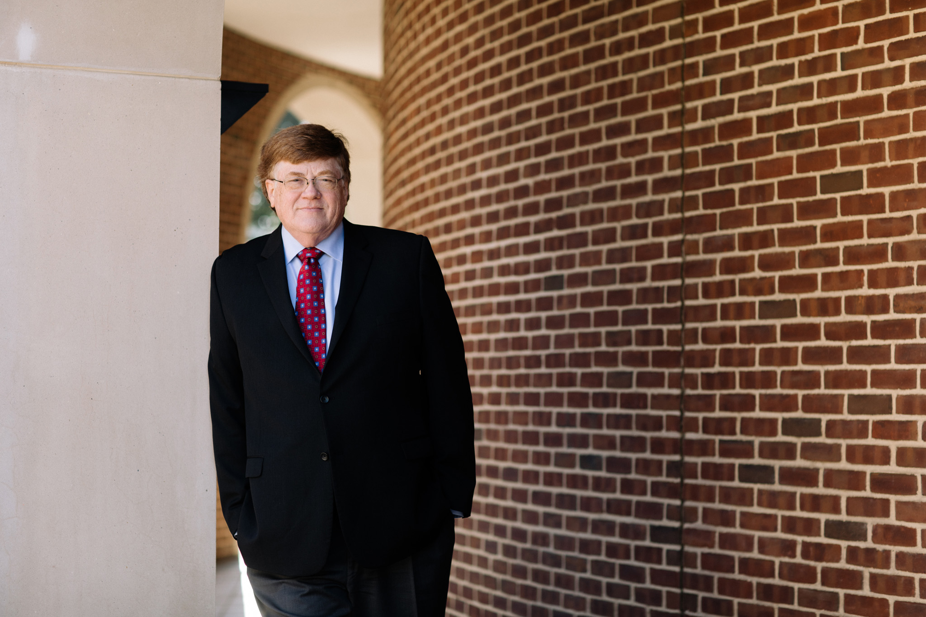

***We know you’re good, now are you ready to get even better?***

**Visit *Pancero.Com* to Enhance Your Sales and Sales Management Training**

[**Follow Jim on Linkedin**](http://www.linkedin.com/in/jimpancero) Jim is posting 3 new sales leadership videos each week on LinkedIn and Facebook! All aimed at helping you become a stronger leader of your sales team. You can view all of Jim’s past LinkedIn postings by putting hashtag #PanceroVids in the LinkedIn search window.

**Articles for Sales Pros and Sales Managers** to help you with In-House training [Click Here](https://pancero.com/articles)

**MP3's** - MP3 audio training by Jim that can be played from your phone or tablet. [Click Here](https://pancero.com/videos/audios/)

**80+ Videos** - Watch training videos. Sales and Sales Management topics are covered. [Click Here](https://pancero.com/videos/)

**Evaluate Your Skills! Free 20 Question *Sales* and *Sales Leadership* Tests!**

The 20-question multiple choice ***Sales Evaluation for sales reps***is a comprehensive analysis tool designed to help you as a sales rep increase awareness of your strongest selling skills. [Click Here](https://pancero.com/sales/sales-pro-evaluation/)

The goal of the 20-question multiple choice ***Sales Leadership Evaluation*** is to help improve your ability to lead a sales team. [Click Here](https://pancero.com/sales-leadership/sales-leadership-evaluation/)

Both tests can be taken multiple times to see how your skills are increasing and all tests results and analysis are instantly available online and emailed.



[**Connect with Jim on Linkedin**](http://www.linkedin.com/in/jimpancero)

[**Sign up for email updates!**](https://pancero.com/contact/)

