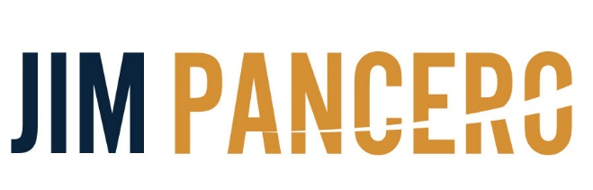
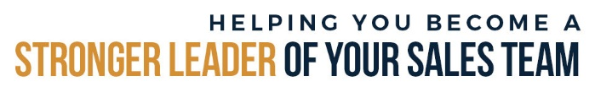

Advanced Sales & Sales Leadership Training & Consulting

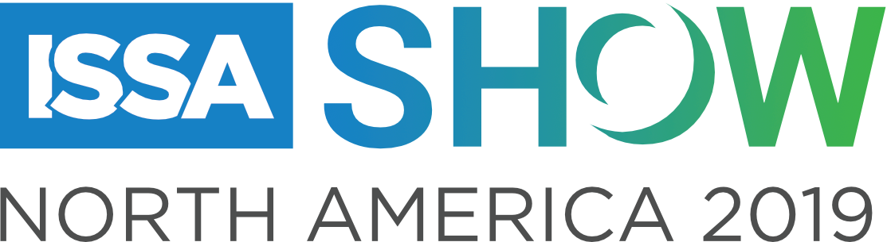

Present
“Winning Selling Strategies for Today’s Disruptive Sales Realities”

Questions? You may contact Jim at:
952-913-8998
jim@pancero.com

Name _________________________________________________________________________________
© Copyright 11/2019 Jim Pancero, Inc. Dallas TX
www.pancero.com
ABOUT JIM PANCERO

If you are interested…open… and ready to improve your team’s success, then Jim Pancero has answers for you. The proven selling philosophies, processes and structures Jim shares all have just one goal…to increase your personal “Powerhouse Selling Advantage.” The leading-edged ideas Jim shares have been researched, validated and fine-tuned through his over 30 years influencing and guiding top performers selling higher priced and/or competitively complex distribution materials, large equipment, or business services. Jim has conducted extensive work within the agricultural industry including training over 3,500 John Deere dealer team members in the US and Canada.

Even during a sixty-minute keynote, Jim’s combination of humor and real-world examples provides even experienced audience members who think they’ve heard it all before and are convinced there’s nothing new in sales with immediately implementable concepts that work. Jim’s proven concepts center on showing you ways to strengthen the messaging and positioning of your uniqueness and value, gaining more control of your selling processes, and strengthening your leadership team’s abilities to coach and lead in today’s hyper-competitive economy and global marketplace.

Jim’s background includes being a top performer selling large computer systems for the Data Processing Division of the IBM Corporation. During Jim's prestigious IBM career, he earned several awards including the coveted "Golden Circle" designation annually awarded to the top 5% of their international sales force.

Since founding his sales training and consulting company in 1982, Jim has conducted over 3,100 speeches, in-depth seminars or consulting days for more than 600 companies in over 80 different industries. Over 90% of Jim's clients have utilized his ideas and services more than once. Jim has also been recognized by the National Speakers Association having earned their CSP (Certified Speaking Professional) designation and been inducted into their Speakers Hall of Fame. This combined honor has only been awarded to less than 3% of their 3,500 professional members.

For more on how to increase your competitive selling advantage visit Jim’s Pancero.com website, join him on LinkedIn (jimpancero), and check out his video clips on YouTube® (YouTube channel “2Sellmore”) and Vimeo.

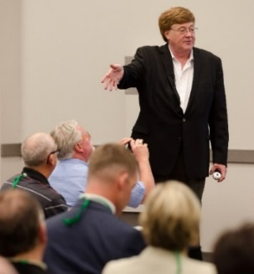
“We know you’re good. Now the only question is…are you ready to get
even better?”

HAVE YOU NOTICED SELLING HAS GOTTEN TOUGHER THE LAST FIVE YEARS?

- Most buyers have embraced today’s Millennial-led buying philosophies

- Rather text than talk

- Rather interact with you electronically than in person (or by phone)

- Comfortable ignoring any of your voicemails, e-mails or texts

- The less connected they feel to you and your company, the less likely they
will be to return your phone calls, e-mails or texts

- Less vendor loyalty

- They assume (or even see) few differences between you and your competitors

- Hard to get a buyer’s attention when they see online how many competitors you
have in the area

- Only wants to talk with salespeople after deciding what they want to buy

- Expect everything next day

SIX THINGS YOU CAN START DOING TODAY TO WIN MORE BUSINESS

1st – Improve your selling message of value and uniqueness

- This is not the message on your website that can easily be copied by your competitors,
but instead is the message you deliver verbally and in individual electronic
communications

- How are you and your team answering a customer asking “Why, based on all the
competitive opportunities available to me, do I want to buy from you?”

- Avoid using the four oldest (and overused) answers of:

- “Because of our high-quality products, our strong levels of support, our competitive
prices…and you get me!”

- Incorporate the “Four Core Values” selling language. Tell me how you are going to:

- Lower my risk

- Make my life or work easier

- Increase my profitability or lower my total costs

- Increase my competitive advantage

2ND – GAIN MORE CONTROL OF YOUR SELLING PROCESSES

- Steps of a sales call…to make you more persuasive and consistent even under pressure

- “ID to close” new business multiple call selling process…to close more new business

- “January 1st to December 31st” plan to support and grow existing customers

STEPS OF THE DISTRIBUTION SELLING PROCESS

Identify
Close

Step 1 – Set up, positioning and establishing an appointment

- Identify potential selling “Success Factors”

Step 2 - Initial sales call, facilities tour & ID of “next best” opportunity to promote

- Can you position your customer’s evaluation/decision process by recommending your four questions?

1. What’s my total cost?
2, Can you support me?
3. How much risk am I taking doing business with you?
4. How will you help me improve my business?

- What step are you on as an organization?

1st – Decide pain
2nd – Decide direction
3rd – Decide solutions
4th – Decide vendors
5th – Decide process

Step 3 - Do more research/positioning and get “higher wider & deeper”

Step 4 - Proposal positioning & delivery

Step 5 – Justify your “Higher Price – Lower Total Cost” philosophy

Step 6 – Post sale support to identify and position your next application solution

Step 7 – Evaluate, adjust & prepare for your next sale

Step 8 – ID next new application – Go back to Step 2

STEPS OF A SALES CALL

1st - Lower resistance

2nd - Ask questions and qualify

- ID customer needs.

- Learn/understand their environment.

- Qualify the relevance and appropriateness of your solution.

3rd - Present your solution

4th - Close

- Where do we go from here?

- What happens now?

- What do we need to do next?

5th - Agree to your next contact

3RD – USE ON-SITE PROBLEM SOLVING TO BLOCK ONLINE COMPETITORS

- You need a team of Arsonists…not Firefighters

- Proactive efforts increase customer loyalty

- We need to stop the reactive calls on existing customers only asking them:

- “Anything you need?”
- “Anything coming up?”
- “Anything I can help with?”
- “How’s the family?”

- Develop a “January 1st to December 31st” full year sales messaging campaign

- Theme for year could be “Making your life safer, easier, and at a lower total cost”

- Each month focus on a different customer problem or challenge you can provide
solutions

- Define each month by benefits – not your products

- Monthly theme examples:

- Helping improve your work-place safety
- Helping reduce your chemical waste (when crews overmix their cleaning chemicals, etc.)
- Lowering your paper (or packaging) costs
- Improving your food packaging
- Equipment operations safety coaching and training
- Reminder of your emergency delivery program
- How can we make our ordering process easier for you?

- You can still have product specials and packages available (Just make sure your reps do not lead with the products!)

- These different themes give your reps a great excuse to get higher, wider and
deeper within their customer by interviewing various department heads
and front-line workers over the year

- Keep reminding your buyers how you will likely not be their lowest price at any given
time…but your offers to help by bringing them solutions can make you their lowest
total cost
4TH – INCREASE YOUR NEW BUSINESS PROSPECTING

- New business prospecting can be:

- Finding new business within an existing customer

- Finding new customers

- Target your prospecting to increase your efficiency and effectiveness

- Better to target a few specific industries (or types of businesses) to prospect

- Customers would rather buy from specialists, not generalists

- The more you call on an industry, the more you pick up their language and areas
of greatest need

- What industries or types of businesses have you had the most success in past
prospecting efforts?

- Define time each week for prospecting

- Define minimum expected prospecting contacts per week

5TH – STRENGTHEN YOUR ELECTRONIC FOOTPRINT

- The size (and strength) of your company is now measured by your electronic footprint

- Website (Including complete product catalogue, technical information, pricing and online ordering)

- Does your website look as strong (or stronger!) compared to the national players?

- Are reviewing and ordering products on your site easy, simple and fast?

- Can I live-chat online with a member of your team?

- LinkedIn

- Have a spokesperson join and participate in groups that are most relevant to your
targeted buyers

- LinkedIn is not a place to sell

- You will get the most attention and build the most connections by helping
others

- The goal is to share helping ideas to solve problems common to the group
so you can start conversations that evolve into the opportunity
to sell

- Post relevant “How to do” or “How to fix” or “How to know if you have a problem”
videos in your LinkedIn groups and on your website

- Interview your customers (all levels and ages) asking which online platforms they
follow

- They will define the best platforms you need to be working to grow your
presence and sales

6th – BECOME A STRONGER COACH AND LEADER OF YOIUR SALES TEAM

- Are you spending the majority of your time acting as “Head Doer” and little time as “Head Selling Coach”

- Majority of sales managers are currently carrying some territory responsibilities

- The greater your personal selling responsibilities as a manager…the more reactive you will be as a coach and leader of your sales team

- Sales managers function more as “Transactional” sales managers than as “Selling Process”
coaches and leaders of their sales team

Proposal or Price Quote Issued
Selling Process Coaching
Transactional Coaching
IDENTIFY
CLOSE

- Transactional Sales Coaching

- Reactive – Starts after proposal is issued – “My door is always open to help”

- Major focus is to help close the business with minimal loss of margin

- “Cut it to win it”

- Selling Process Coaching

- Proactive – Starts involvement before rep makes first call on prospect (optimum) – “Get
in here and tell me how the Jones account is progressing.”

- Major focus is to help define account selling strategy and multiple stepped tactical implementation plan

- “Get it set up correctly from the beginning”

HOW TO DEVELOP A CULTURE OF ONGOING SALES TRAINING

- Best sales training is conducted weekly

- Attendees can join meeting by video chat (Zoom, Facetime, Skype, GoToMeeting)

- Training works best when it is an ongoing full-year process (not just a few random
training events)

- Easiest format for training…Show a video then lead a discussion

- Total time can be as little as 20 minutes

Step 1 – Show a brief video to introduce a new selling idea or challenge
Step 2 – Lead your team in a discussion by asking three questions:
- Question #1 - “What did you think of the video?”
- Question #2 - “How relevant are those ideas to our industry and company?”
- Question #3 - “What are you going to do/try different based on what we’ve learned
from this video?”
- The most learning occurs when you ask the most questions (and do the least
amount of talking/lecturing)
Step 3 – (After your training class during the week) – Keep asking how the new idea is
working
- During normal conversations ask if they’ve had any success with the new
ideas discussed

- Free sales training videos

- Hubspot’s article “The 34 best sales training videos on YouTube” - I’m #10 on their list

– https://blog.hubspot.com/sales/sales-training-videos-youtube

– “Your Price is Too High – 7 Steps to Defending Price”
https://youtu.be/YNeFi1RwL6c
- My free videos!

– YouTube https://www.youtube.com/c/JimPancero

– Connect with me on LinkedIn where I am posting four videos a week on sales and
sales leadership (all under four minutes) https://www.linkedin.com/in/jimpancero

– Subscribe to my free Friday e-newsletter that includes links to all videos posted
that week https://Pancero.com

- More in-depth sales video training – www.AdancedSalesUniversity.com
Visit Pancero.Com to Enhance Your Sales and Sales Management Training
We know you’re good, now are you ready to get even better?
Follow Jim on Linkedin Jim is posting 3 new sales leadership videos each week on LinkedIn and Facebook! All aimed at helping you become a stronger leader of your sales team. You can view all of Jim’s past LinkedIn postings by putting hashtag #PanceroVids in the LinkedIn search window.

Articles for Sales Pros and Sales Managers to help you with In-House training Click Here

MP3's - MP3 audio training by Jim that can be played from your phone or tablet. Click Here

80+ Videos - Watch training videos. Sales and Sales Management topics are covered. Click Here
Evaluate Your Skills! Free 20 Question Sales and Sales Leadership Tests!
The 20-question multiple choice Sales Evaluation for sales reps is a comprehensive analysis tool designed to help you as a sales rep increase awareness of your strongest selling skills. Click Here
The goal of the 20-question multiple choice Sales Leadership Evaluation is to help improve your ability to lead a sales team. Click Here
Both tests can be taken multiple times to see how your skills are increasing and all tests results and analysis are instantly available online and emailed.
Connect with Jim on Linkedin
Sign up for email updates!

